**Lab Practical #04:**

Installation of Network Simulator (Packet Tracer) and Implement different LAN topologies.

**Practical Assignment #04:**

1. **Create a simple network with switch and two or more pc. Also check connectivity between them using ping command or PDU utility.**
2. **Implement different topologies in packet tracer.**
   1. **Bus**
   2. **Ring**
   3. **Star**
   4. **Mesh**
   5. **Tree**

**simple network**:

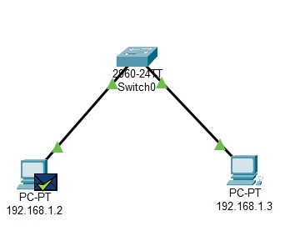

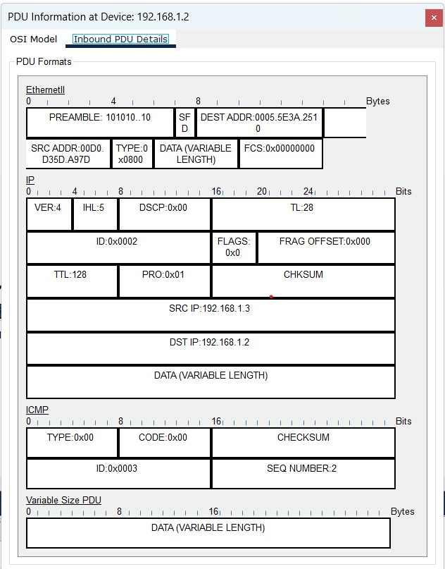

1. **Bus**

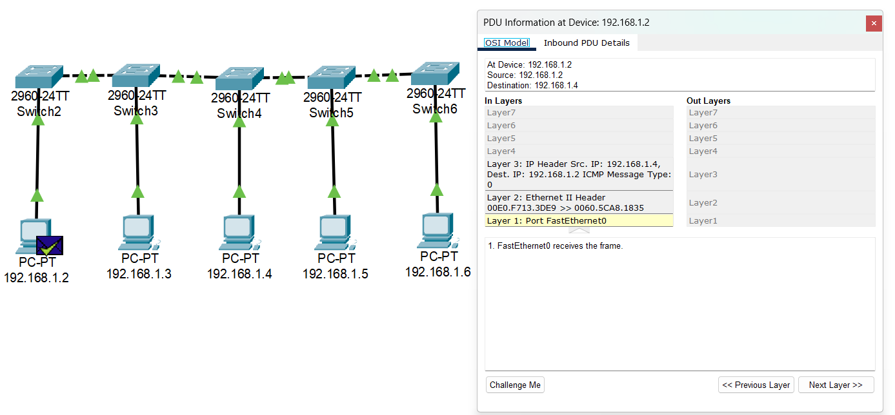

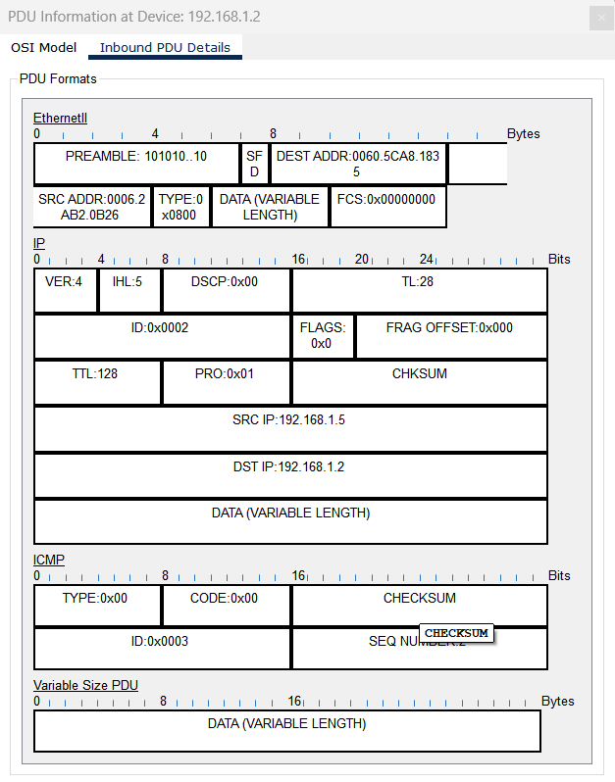

1. 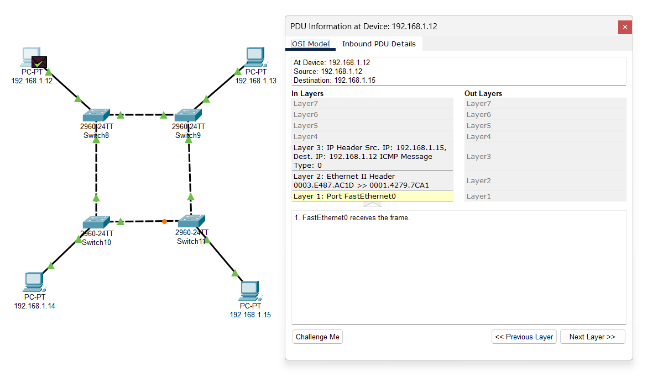**Ring**

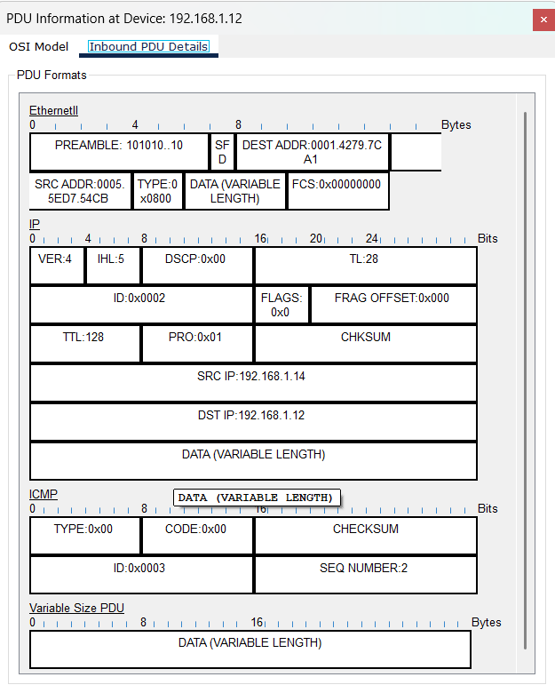

1. 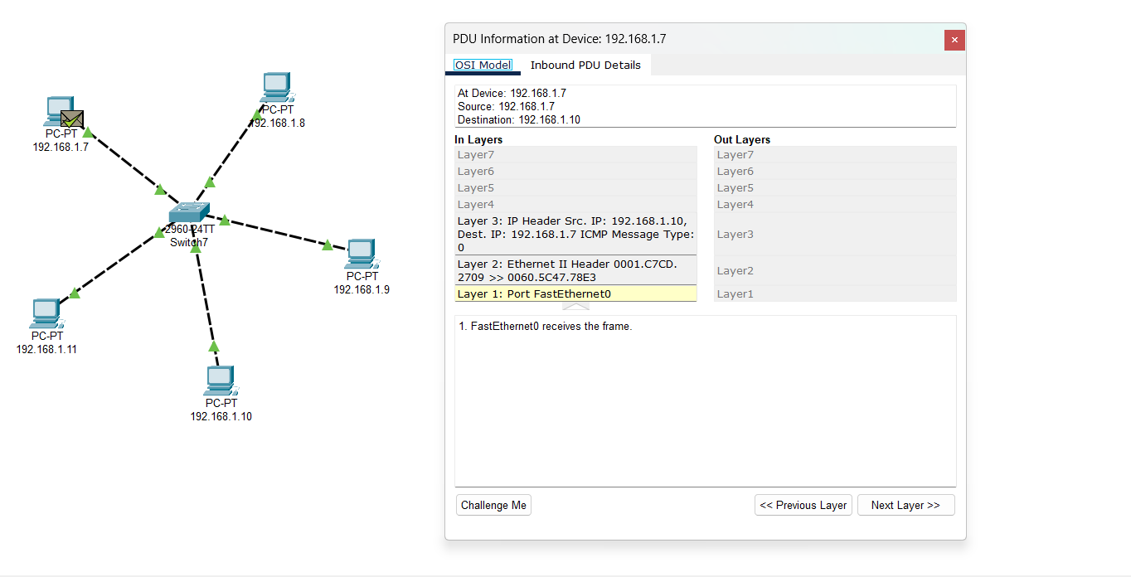**Star**

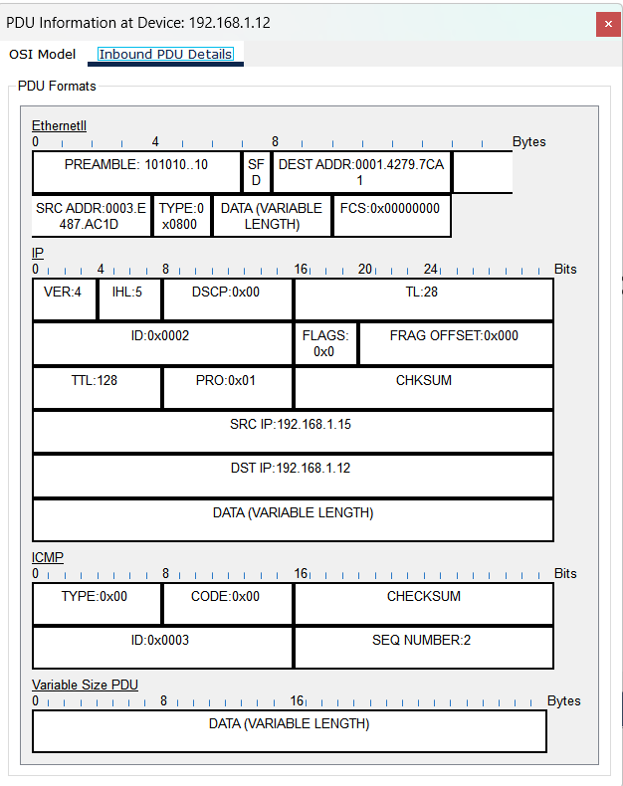

1. **Mesh**

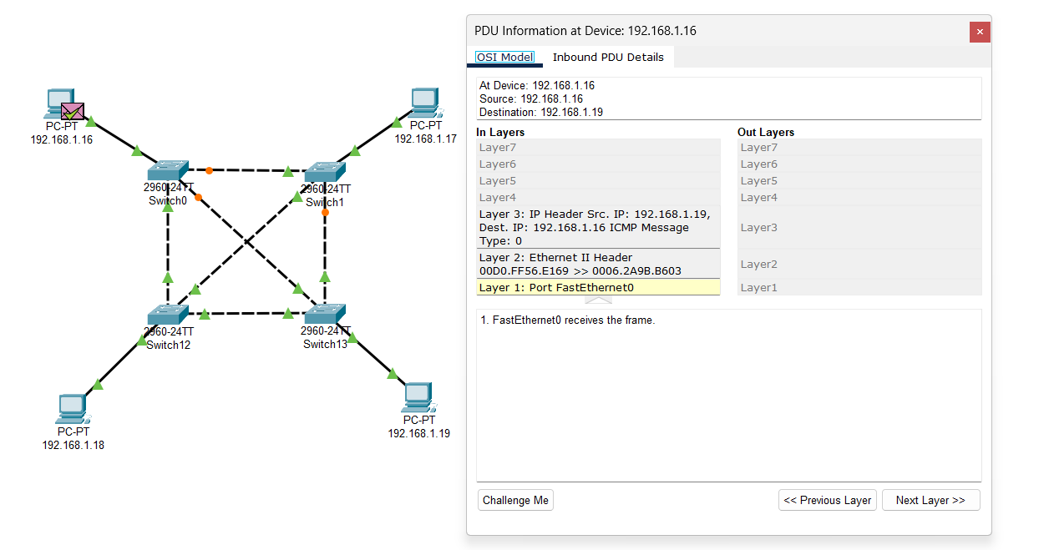

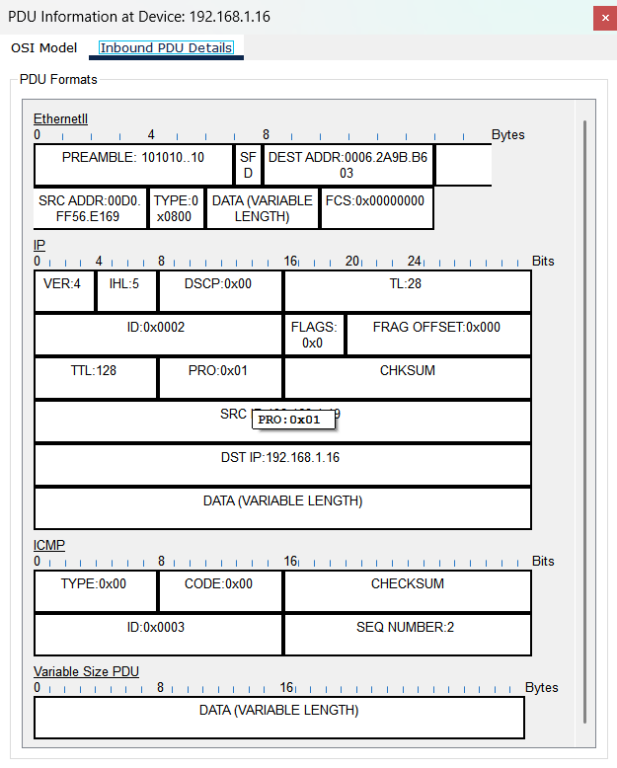

1. 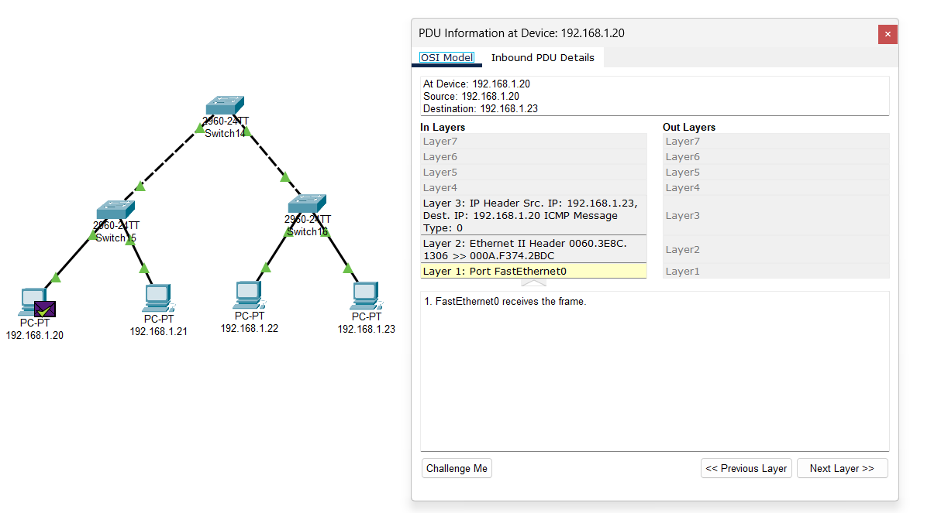**Tree**

